# CS 255 System Design Document Template

## UML Diagrams

### UML Use Case Diagram

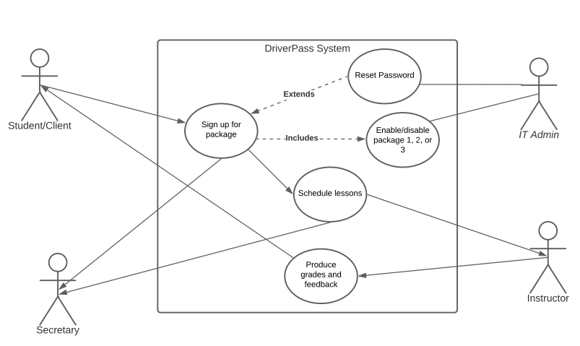

### UML Activity Diagrams

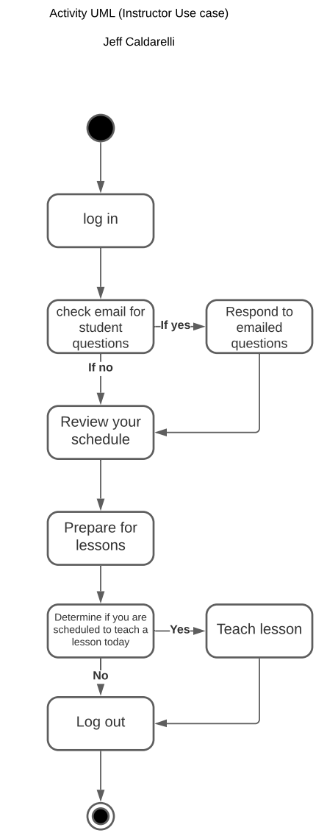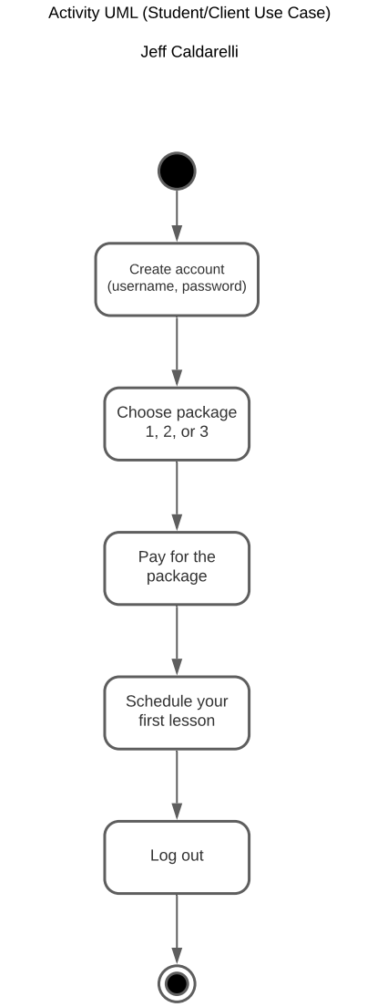

### UML Sequence Diagram

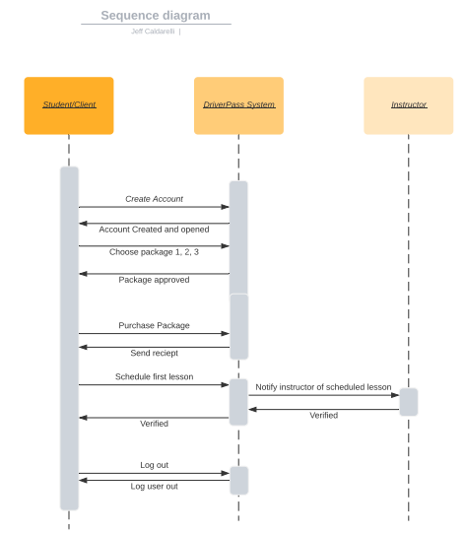

### UML Class Diagram

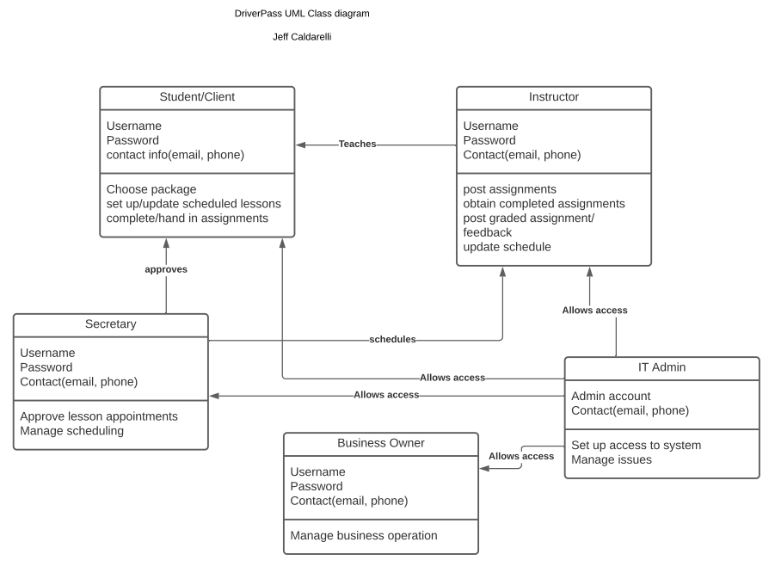

## Technical Requirements

The technical requirements, based on the diagrams above as well as the previously outlined functional and non-functional requirements, include the following:

* A Linux cloud-based platform
* A server to house the DriverPass database
* The back end for this system does not require any additional database tools or support, as it is cloud based and has the clouds security and database support.
* The system should be updated periodically in order to operate efficiently
* The user will require online accessibility